Name: Manan Malik

Reg no: 22BEC1245

DISPERSION COMPENSATION

**Aim:**

To study the dispersion compensation using

* + - Dispersion compensation fiber (DCF)
      * Pre, Post, Pre-post (symmetrical)

**Software Required:**

Optisystem 21

**Procedure:**

1. Open the optisystem 21.
2. Get the components from the component library and arrange accordingly.
3. Now take the readings of Q-factor, BER and average received power for the input signals with different given power.
4. Repeat the same for all three types.
5. Before taking all these readings run the system.

**Pre:**

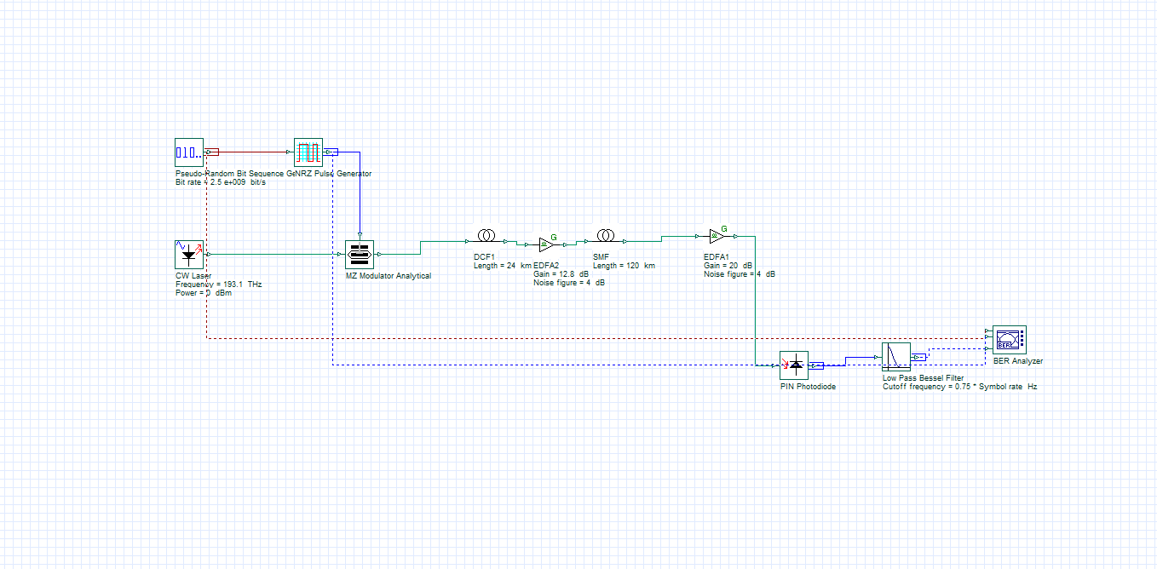

**0 db**

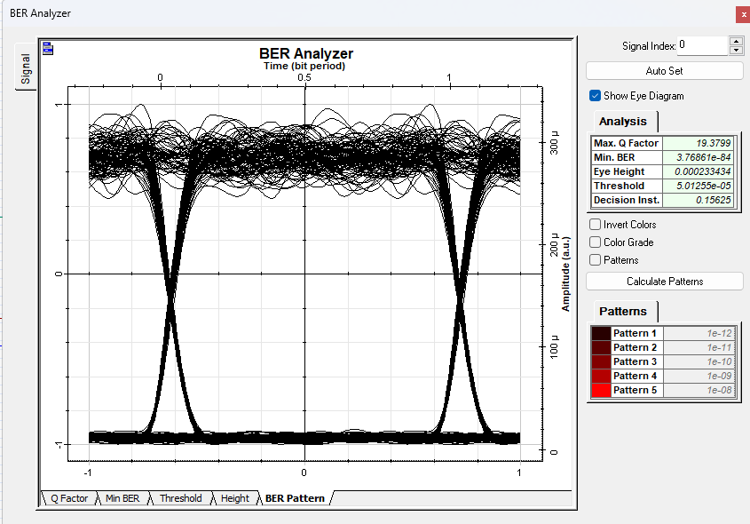

**5 dBm**

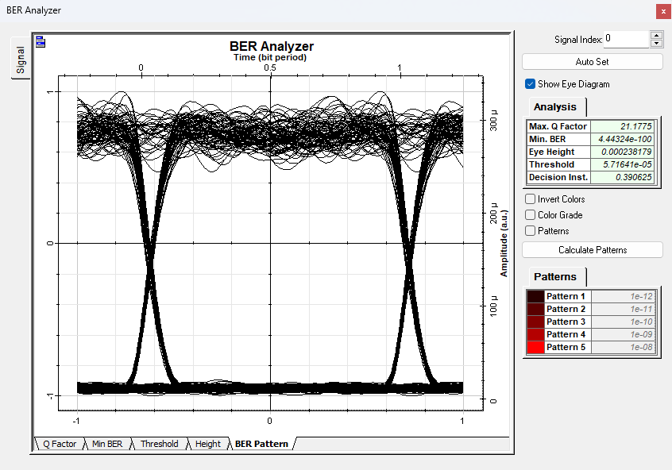

**10 dBm**

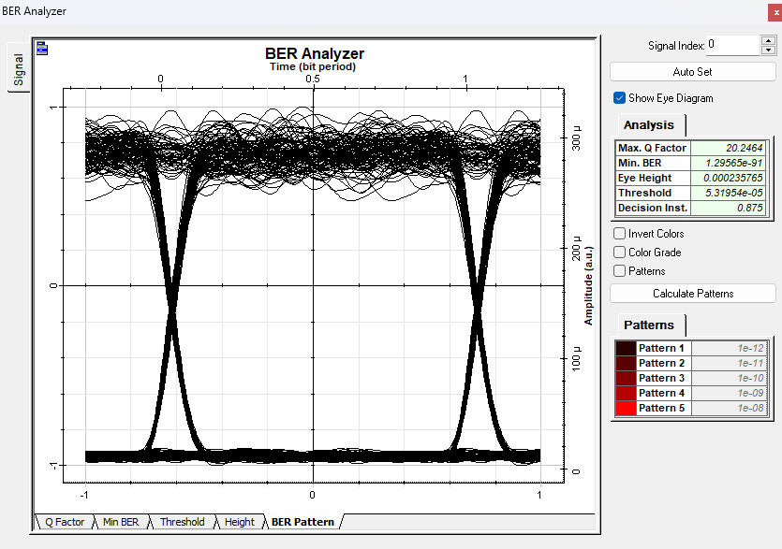

**15 dBm**

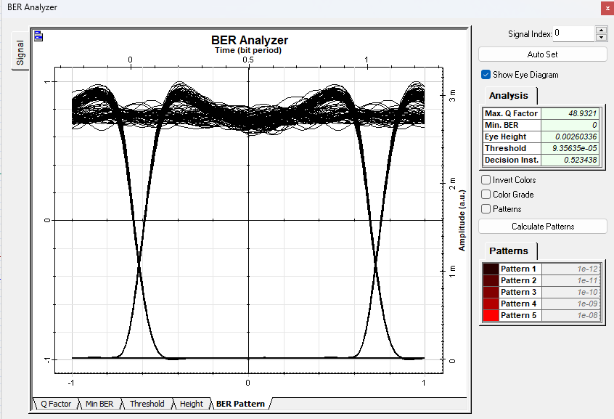

**20 dBm**

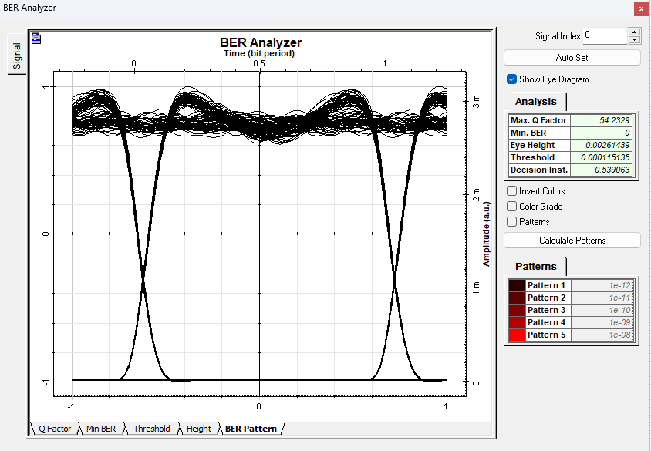

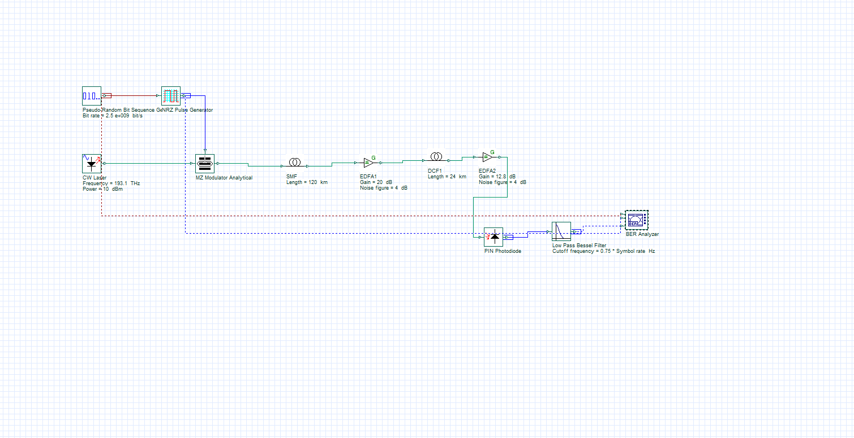**POST**

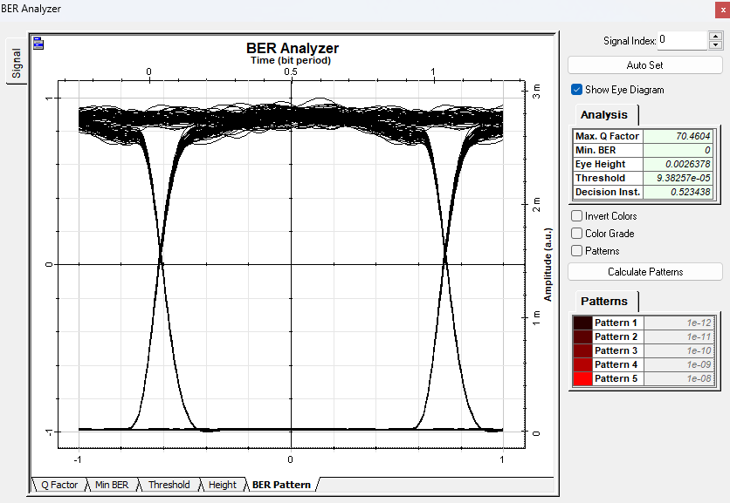**0dbm**

**5dbm**

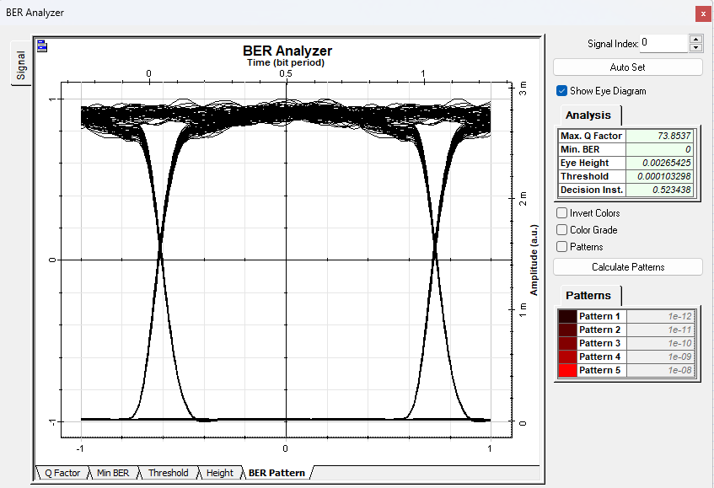

**10dbm**

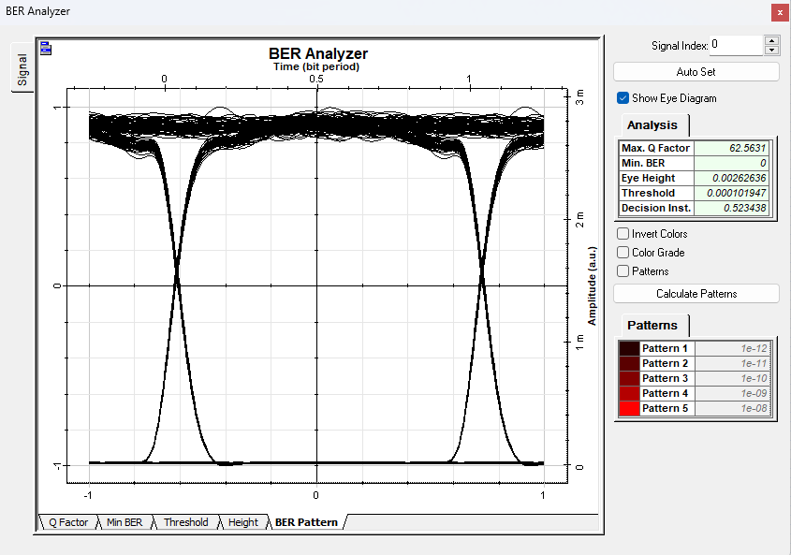

**15 dbm**

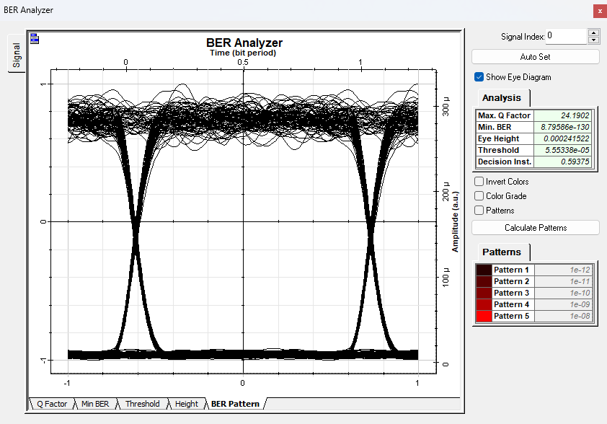

**20 dbm**

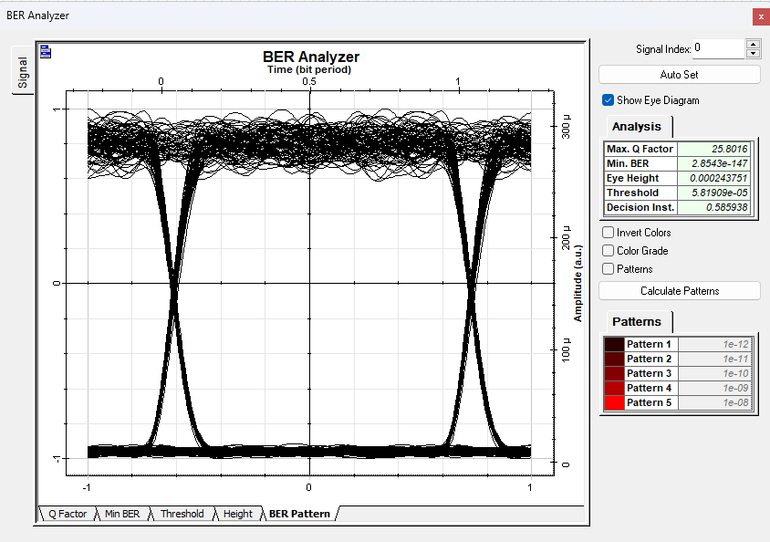

pre post

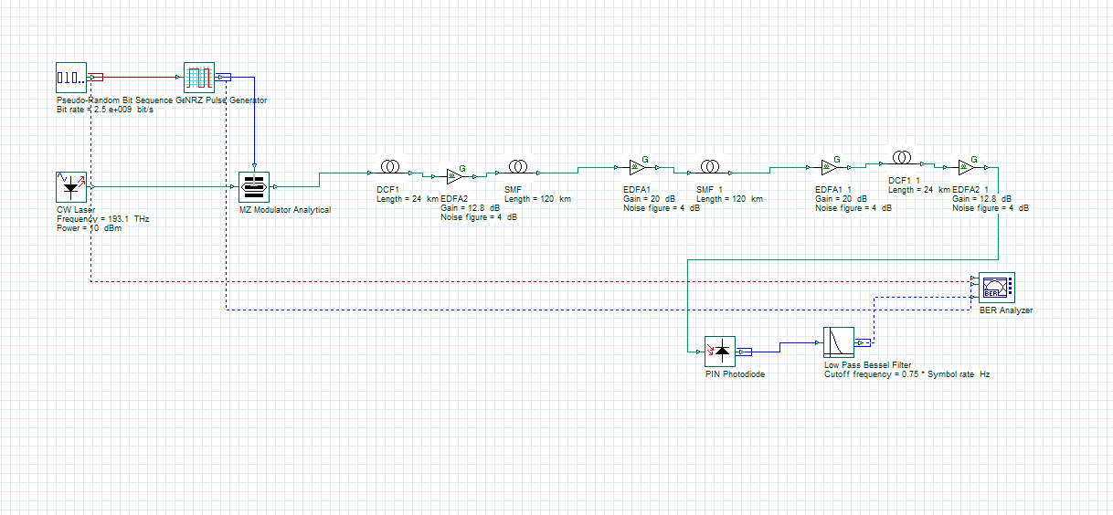

**0 dbm**

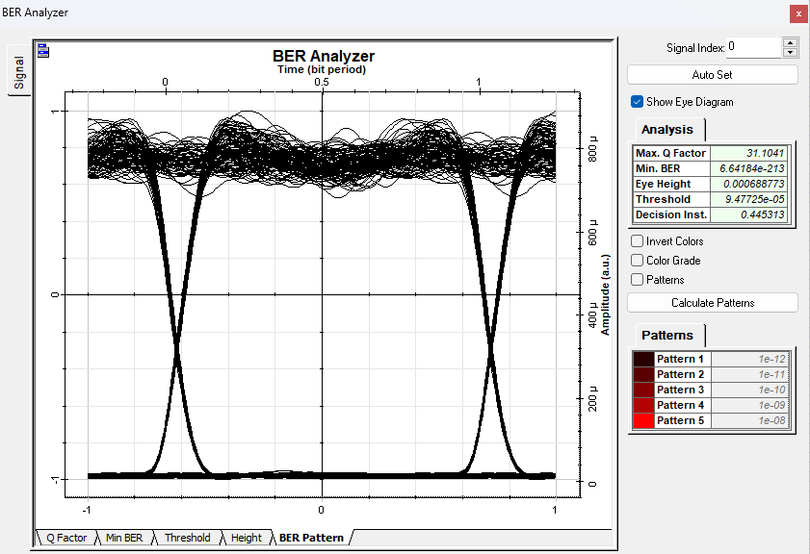

**5 dbm**

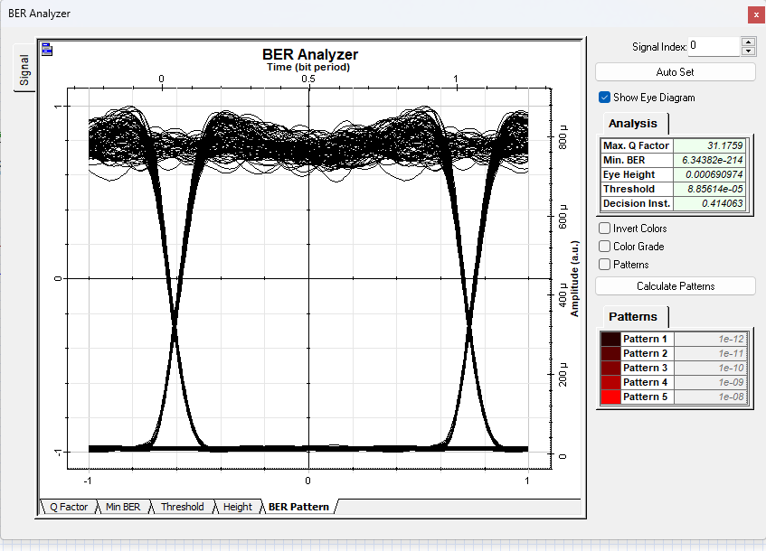

**10 dbm**

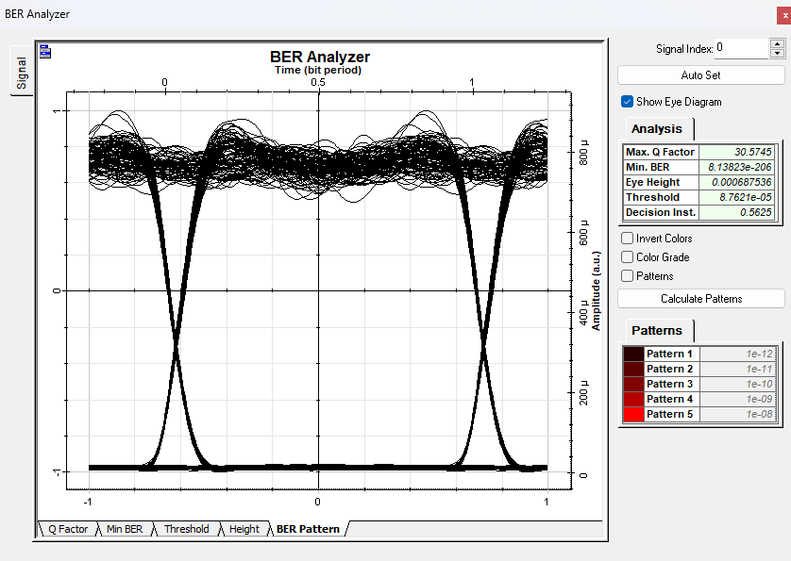

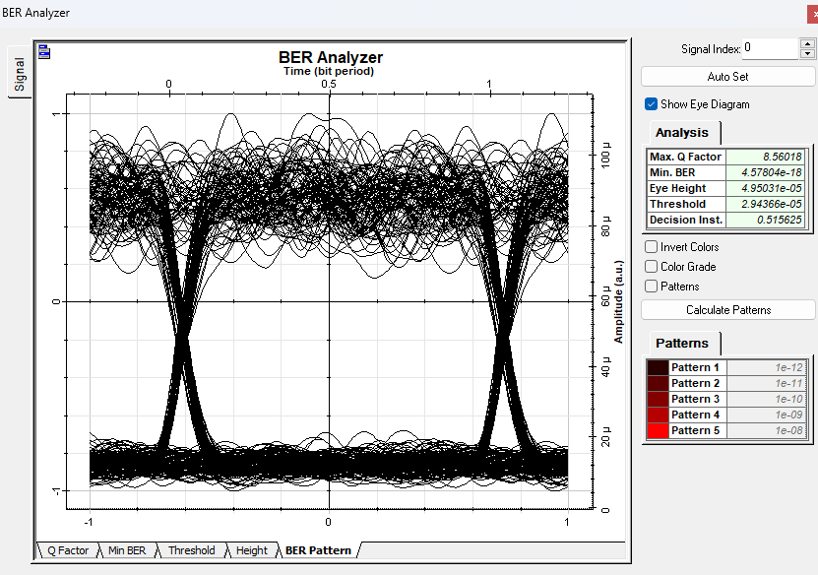**15 dbm**

**20 dbm**

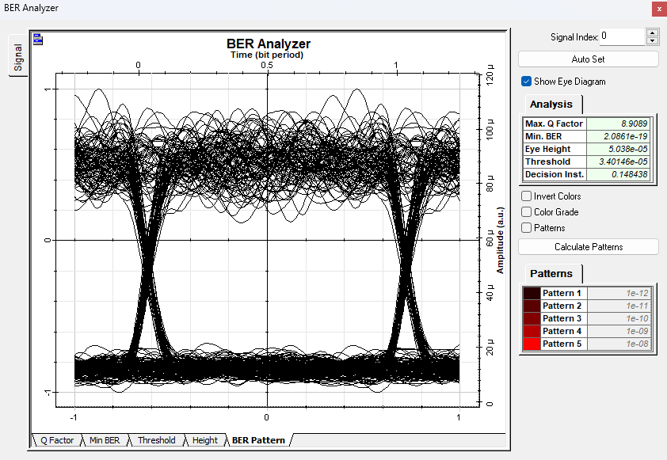

**Observation:**

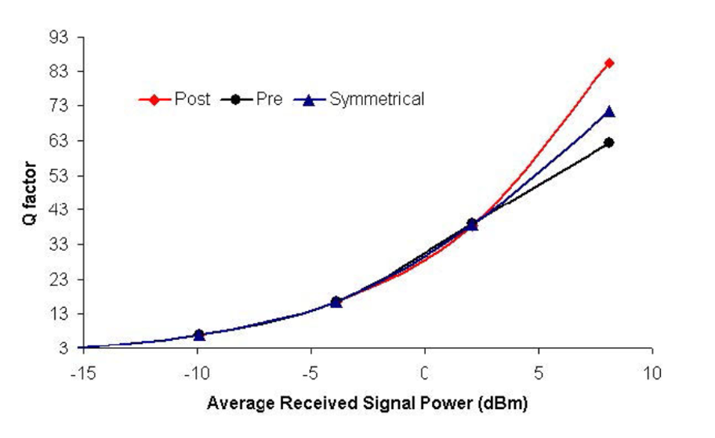

**Conclusion:**

Hence analysed the BER, Q-factor and average power for 0dBm, 5dBm, 10dBm, 15dBm and 20dBm of pre, post and pre-post

compensation.